Rhiannon Foster 421577

Software design and development

Contents

Introduction 2

Data Types 2

# Introduction

When you program you need to choose a language to program in and what data types you should use. This is hard to do when you do not know why or how to choose them. There are also different software structures that you can use.

# Data Types

We need variables to be able to build a program, there are lots of different types that you can use for different things.

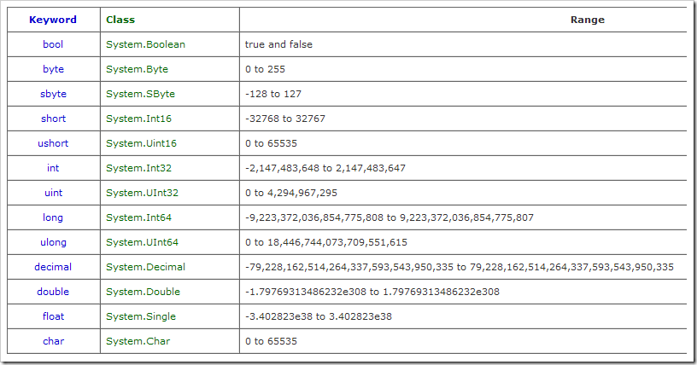

Different data types make the program more user friendly, computers only work with binary language but users will not understand this so the computer can change the language into English, the best data types that show this are integers, real, Boolean, character and string.

An integer is a whole number such as 37 or 90, these are useful for counting or choosing a menu option. They usually take up less memory because they do not show the fractional part of the number.

In order to make the program more readable the programmer names the variables. In order for this to make any sense the creator needs to make sure it is meaningful, if there is a temporary variable then it doesn’t matter if it is a single letter.

Real numbers are a number with a decimal place, for example 9.78. this can be used for money, fraction, division, measurements.

Strings are the data types that are most familiar to humans, these are words but could contain numbers. They can take up lots of storage as it could be a long number but then again it could also be a single letter.

A character is a single letter, this can be ASCII or Unicode, Unicode takes more memory.

Boolean variables can only be either true or false, we say that it holds either a yes or a no, this is good for questions. These are usually used in selection following an IF statement to decide which lines will run and which will not.

You need to declare data types which will then make it available to reference throughout the program and the variable needs to be declared before executable statements.

It is very important to have different data types because of storage reasons, if you do not declare the variable then it could be lost. Using data types means that you are allocating storage of the correct size to save. To add, it could also crash the program and it will not work.

Having declared the variable you can use this as additional validation, if you declare that the variable is a char and then the user enters a number it will not work properly so instead of using more lines of code you could use the declaration which is more efficient also.

# Software Structures

In computer programming a sequence is single statements after each other; an example of this is:

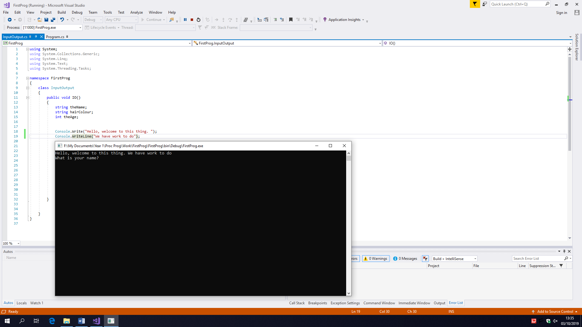

This is a basic output which, when you run the program will output a sentence.

Another example of the code is:

This will ask the user what number is halfway between 13 and 14 and then wait for the user to enter a number and will say that it is correct

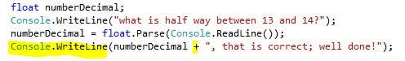



Selection is a conditional statement, which is also known as decisions.

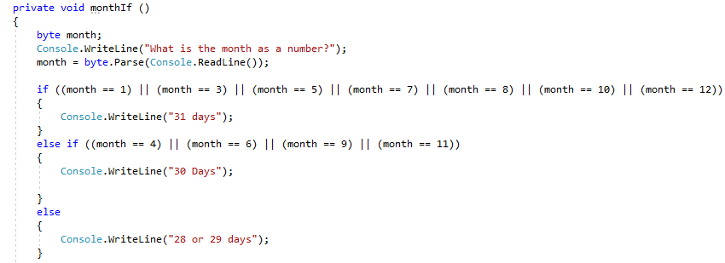This code snippet shows that when the user enters a month as a number it will then display how many days are in that month. This is selection because it is using an if/else statement.

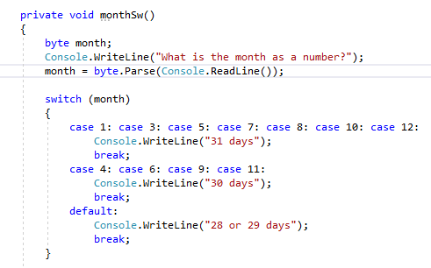 Another example is this:

Iteration is when the program continues until it Is told to stop, to do this you will have to use a for, while or do, while:

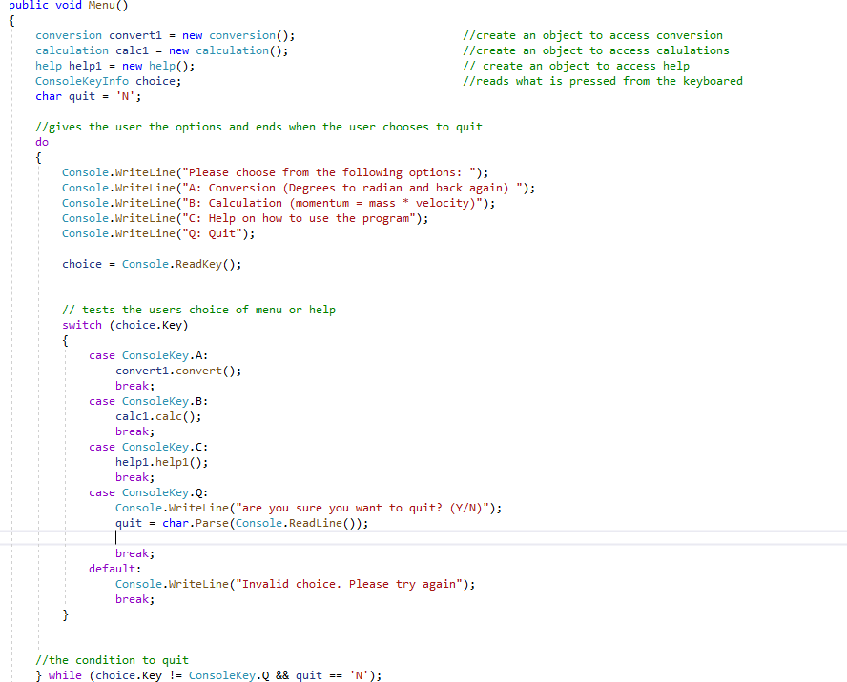

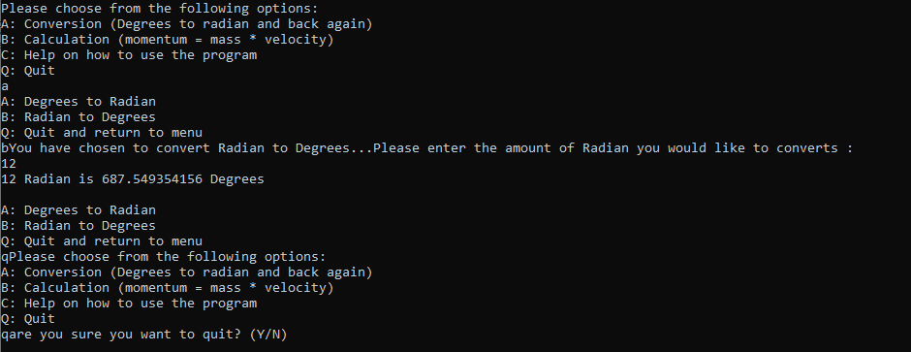

This is how the program will work when the user sees it. This continues to run until the user chooses to quit.